Lick Observatory

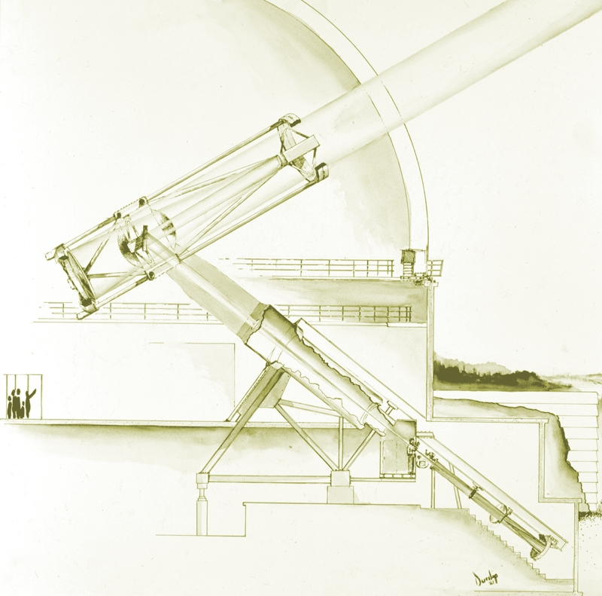

Telescope Maintenance
&
Operations Manual

3

